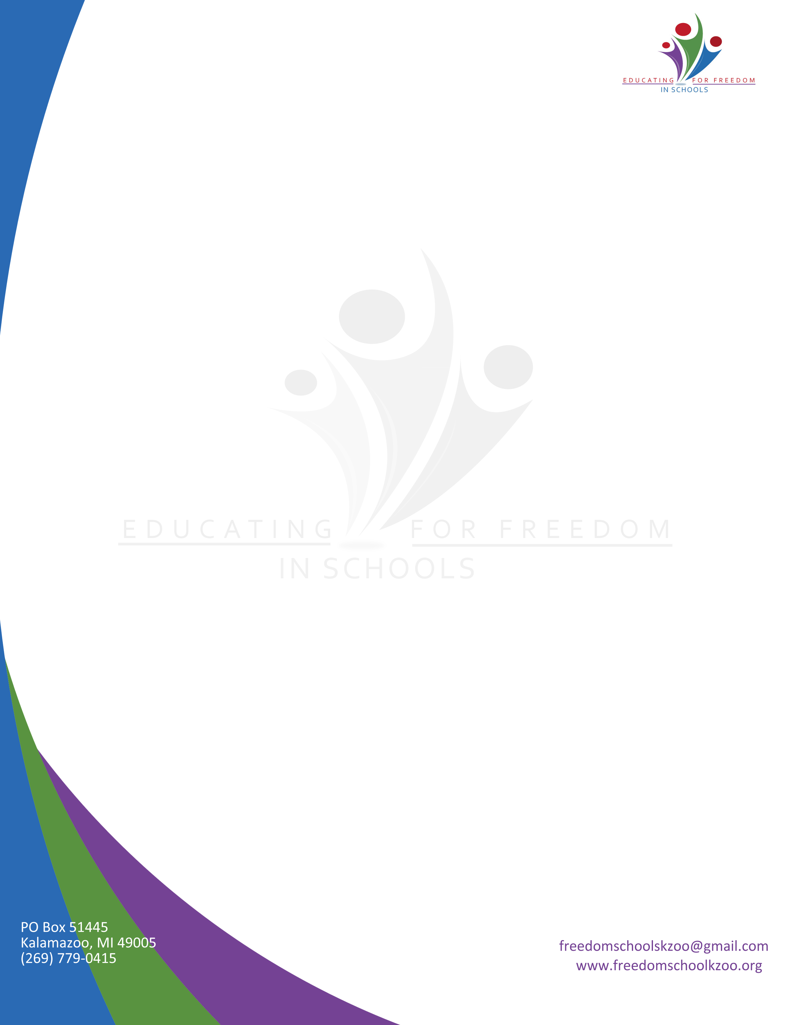

**CDF Freedom Schools® Program**

**Youth Development Professional**

**Job Posting**

Educating for Freedom in Schools (EFIS) is a 501c(3) youth development organization focused on providing high-quality, culturally relevant programming that is accessible to all youth, regardless of income. CDF Freedom Schools® is a program of EFIS that is a national, best practice model that is focused on literacy, social justice, health/wellness, intergenerational leadership development, and family engagement for K-8 grade youth. To learn more please visit [www.educating4freedom.com](http://www.educating4freedom.com).

EFIS is looking for passionate individuals to work as a Youth Development Literacy Instructor for a CDF Freedom Schools® afterschool program starting by early October at Spring Valley Elementary School. The program will be offered on Monday, Tuesday, and Thursday from 4:00 PM-6:30 PM and is scheduled to end late May, 2017. Enrichment and service learning activities will also take place one Saturday per month. No teaching experience is necessary-we will train the right people!

The following are duties particular to a Youth Development Professional with CDF Freedom Schools®:

* Work independently to oversee up to 10 students in the classroom or co-dependently with another staff person to oversee up to 20 students
* Develop weekly lesson plans
* Provide daily lesson instruction
* Provide the context to have challenging conversations about social justice related topics
* Assess and monitor the reading, writing, critical thinking, and behavior of students
* Create content to go in parent newsletter
* Communicate with parents as needed in order to keep them abreast of their child’s progress
* Attend parent meetings
* Other duties as assigned

To apply please submit a cover letter, resume and three references to janai@educating4freedom.com or P.O. Box 19846 Kalamazoo, MI 49009 by September 19, 2016.